## horizontal line

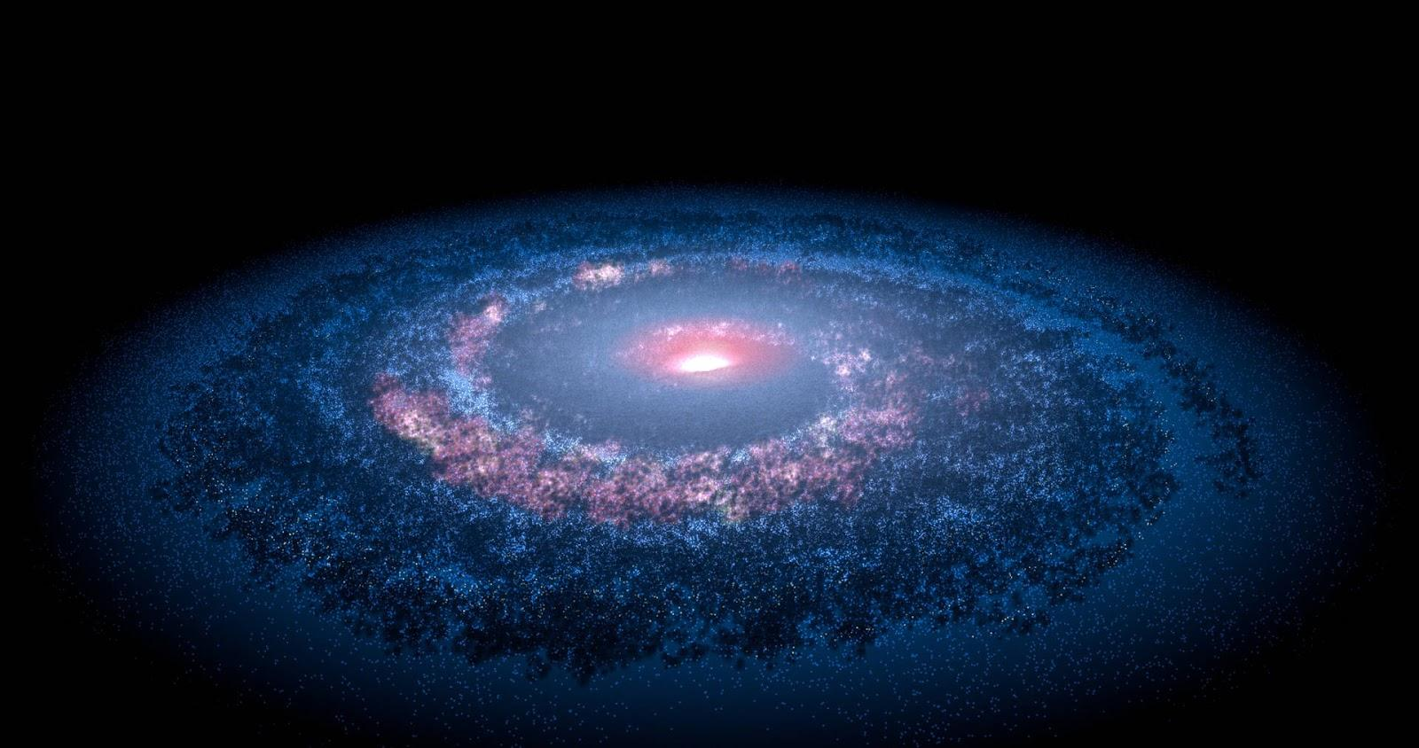

**SPACE-EXPLORATION MANAGEMENT SYSTEM -**

***DATABASE DESIGN, CONCEPTUAL ERD***

**GROUP 2  
  
  
  
TEAM MEMBERS:**  
**Dhwanil Jigneshbhai Panchani - 002840688**  
**Shalini Dutta - 002235745  
Zeel Patel - 002242786  
Atharva Sunil Konge - 001004607  
Bodhireddy Kiran Reddy - 002812499**

# 

**OVERVIEW**

The database design for our space exploration project focuses on meticulous organization and comprehensive data management to support the overarching goal of enhanced space mission planning and execution. The entities outlined, including Mission, Spacecraft, Astronaut, LaunchSite, Payload, LaunchVehicle, Agency, ScientificInstrument, CommunicationSystem, MissionObjective, FuelConsumption, and TimeConsumption, form the backbone of a database system meticulously crafted to store, retrieve, and manage data efficiently. Each entity is equipped with attributes that capture the critical aspects of space missions—ranging from mission specifics like name, duration, status, and purpose to detailed characteristics of spacecraft, such as type and payload capacity, and personal profiles of astronauts. Primary keys ensure data integrity and uniqueness, while foreign keys facilitate relational links between missions and various operational components, enabling a multi-dimensional analysis of mission-critical data. This structure supports our objective of creating a centralized information hub that enhances decision-making and operational efficiency.

Our project's objective is to harness this database's power to streamline space exploration efforts by optimizing mission planning, facilitating seamless communication among different teams, and implementing advanced risk management strategies. By centralizing data from diverse aspects of space missions, from the planning stages through to execution and analysis, we enable stakeholders to access a unified view of mission-related information, improving collaboration and coordination across departments and agencies. The database is designed to accommodate complex queries, from tracking the progress of specific missions and analyzing fuel consumption patterns to evaluating the performance of scientific instruments and managing astronaut rosters. This approach not only maximizes resource utilization and mission success rates but also paves the way for groundbreaking discoveries in space exploration, underlining our commitment to advancing human knowledge and capabilities beyond Earth's confines.

**ENTITIES AND ATTRIBUTES**

**Mission**

***Purpose*:** Represents each space mission undertaken, detailing its objectives, resources, timeline, and status.

**MissionID:** Unique identifier.

**MissionName:** Name of the mission.

**LaunchDate:** Scheduled launch date.

**Duration:** Expected or actual duration.

**Status:** Current status (planning, active, completed, etc.).

**Destination**: Target location in space.

**Budget**: Financial allocation for the mission.

**Purpose**: The mission's goal.

**Description**: Detailed overview of the mission.

**Spacecraft**

***Purpose***: Details the vehicles used for space exploration, including their capabilities and operational status.

**CraftID**: Unique identifier.

**CraftName**: Name of the spacecraft.

**Type**: Classification or model.

**PayloadCapacity**: Maximum cargo weight.

**LaunchDate**: Date of launch.

**Status**: Operational status.

**Astronaut**

***Purpose***: Records information about the astronauts, including their background and role in missions.

**AstronautID**: Unique identifier.

**FirstName**: First name.

**LastName**: Last name.

**DateOfBirth**: Birth date.

**Nationality**: Nationality.

**Gender**: Gender.

**Specialty**: Area of expertise.

**LaunchSite**

***Purpose***: Identifies launch sites, detailing their capabilities and geographical specifics.

**SiteID**: Unique identifier.

**SiteName**: Name of the site.

**Location**: Geographical location.

**LaunchCapacity**: Capability in terms of launch logistics.

**Payload**

***Purpose***: Describes the cargo or instruments carried by spacecraft, including their purpose and specifications.

**PayloadID**: Unique identifier.

**PayloadName**: Name of the payload.

**Type**: Type (satellite, scientific equipment, etc.).

**Weight**: Weight.

**Purpose**: Objective of carrying the payload.

**LaunchVehicle**

***Purpose***: Provides details on the vehicles used to transport spacecraft and payloads into space, including their specifications and manufacturers.

**VehicleID**: Unique identifier.

**VehicleName**: Name of the vehicle.

**Type**: Model or type.

**PayloadCapacity**: Carrying capacity.

**Manufacturer**: Manufacturer.

**Agency**

***Purpose***: Records details about space agencies, including their administrative and financial particulars.

**AgencyID**: Unique identifier.

**AgencyName**: Name of the agency.

**Country**: Country of origin.

**Director**: Current director.

**Budget**: Operating budget.

**ScientificInstrument**

***Purpose***: Details the instruments used within missions for scientific research, specifying their types and functions.

**InstrumentID**: Unique identifier.

**InstrumentName**: Name of the instrument.

**Type**: Type of instrument (e.g., sensor, telescope).

**CommunicationSystem**

***Purpose***: Captures information on the communication systems used in missions, essential for data transmission and operational control.

**CommSystemID**: Unique identifier.

**CommSystemName**: System name.

**Type**: System type (e.g., radio, satellite communication).

**MissionObjective**

***Purpose***: Describes the specific objectives of missions, providing a clear goal or set of goals for each mission.

**ObjectiveID**: Unique identifier.

**ObjectiveDescription**: Detailed description of the mission's objectives.

**FuelConsumption**

***Purpose***: Tracks fuel usage by various vehicles and missions, critical for planning and sustainability studies.

**FuelID**: Unique identifier.

**FuelType**: Type of fuel.

**Amount**: Amount of fuel consumed.

**TimeConsumption**

***Purpose***: Monitors time spent on different operations within missions, aiding in efficiency and planning.

**TimeID**: Unique identifier.

**OperationType**: Type of operation (e.g., transit, exploration).

**Duration**: Duration of the operation.

Each entity is designed to capture specific, vital information relevant to its domain within space exploration projects. This structured approach allows for efficient data management and retrieval, essential for the planning, execution, and analysis of space missions.

**RELATIONSHIPS**

**Between LaunchVehicle and Mission**

*LaunchVehicle to Mission ("Launches with"):* This suggests that each mission is launched by at least one launch vehicle, outlining the utilization of these vehicles for missions.

**Between LaunchVehicle and Spacecraft**

*LaunchVehicle to Spacecraft ("Has"):* This indicates that a launch vehicle is capable of carrying multiple spacecraft, defining the carrying capacity of the vehicle.

**Between Spacecraft and Astronaut**

*Spacecraft to Astronaut ("Has"):* This denotes that astronauts are crew members of a spacecraft, establishing the link between human resources and space vehicles.

**Between Spacecraft and FuelConsumption**

*Spacecraft to FuelConsumption ("Records"):* This records the fuel usage of each spacecraft, indicating a tracking mechanism for fuel expenditure.

**Between Spacecraft and TimeConsumption**

*Spacecraft to TimeConsumption ("Records"):* This details the operational time logged by spacecraft, tracking the time spent on various space mission activities.

**Between Spacecraft and Mission**

*Spacecraft to Mission ("Assigns"):* This shows that specific spacecraft are designated for missions, assigning the necessary equipment for mission objectives.

**Between Mission and Astronaut**

*Mission to Astronaut ("Assigns"):* This indicates that missions have assigned astronauts, detailing the human resource allocation for space exploration tasks.

**Between Mission and CommunicationSystem**

*Mission to CommunicationSystem ("Uses"):* This signifies that missions are equipped with communication systems to maintain contact and control, emphasizing the role of communication in mission operations.

**Between Mission and Agency**

*Mission to Agency ("Recorded by"):* This shows that agencies are responsible for documenting and overseeing missions, underlining the administrative link between missions and space agencies.

**Between Mission and Payload**

*Mission to Payload ("Contains"):* This denotes that missions are composed of various payloads, specifying the equipment and materials carried for space exploration.

**Between Mission and LaunchSite**

*Mission to LaunchSite ("Launches from"):* This specifies the geographic starting point of missions, connecting them to their terrestrial launch locations.

**Between Mission and MissionObjective**

*Mission to MissionObjective ("Relates"):* This connects missions to their goals, highlighting the objectives that drive mission planning and execution.

**Between Mission and ScientificInstrument**

*Mission to ScientificInstrument ("Uses"):* This relates missions to the scientific tools they employ, pointing to the utilization of instruments for data gathering and research.

**Between Agency and LaunchVehicle**

*Agency to LaunchVehicle ("Operates with"):* This suggests that agencies manage and operate various launch vehicles, reflecting the logistical aspect of mission preparation.

**Between Agency and CommunicationSystem**

*Agency to CommunicationSystem ("Operates with"):* This implies that agencies manage communication systems, crucial for mission support and data transmission.

**Between CommunicationSystem and Spacecraft**

*CommunicationSystem to Spacecraft ("Operates with"):* This establishes that communication systems are specifically used for spacecraft operations, crucial for in-mission and inter-vehicle communications.

**Between ScientificInstrument and Payload**

*ScientificInstrument to Payload ("Aligns with"):* This shows that scientific instruments are an integral part of mission payloads, essential for conducting experiments and research in space.

**Between Payload and LaunchVehicle**

*Payload to LaunchVehicle ("Has"):* This indicates that launch vehicles are equipped with payloads, which are the cargo transported during the mission launch phase.

**CARDINALITIES**

**Mission to Spacecraft:**

Mandatory One (1) from Mission to Spacecraft (1 Mission must have at least one associated Spacecraft).

Optional Many (N) from Spacecraft to Mission (a Spacecraft may or may not be associated with a Mission).

**Mission to Astronaut:**

Mandatory Many (N) from Mission to Astronaut (1 Mission can have multiple associated Astronauts).

Optional Many (N) from Astronaut to Mission (an Astronaut may or may not be associated with a Mission).

**Mission to LaunchSite:**

Optional One (1) from Mission to LaunchSite (a Mission may or may not have an associated LaunchSite).

Mandatory One (1) from LaunchSite to Mission (a LaunchSite must be associated with a Mission).

**Mission to Payload:**

Mandatory One (1) from Mission to Payload (a Mission must have at least one associated Payload).

Optional Many (N) from Payload to Mission (a Payload may or may not be associated with a Mission).

**Mission to LaunchVehicle:**

Optional Many (N) from Mission to LaunchVehicle (a Mission may or may not have an associated LaunchVehicle).

Mandatory One (1) from LaunchVehicle to Mission (a LaunchVehicle must be associated with a Mission).

**Agency to Mission:**

Mandatory One (1) from Agency to Mission (an Agency must be associated with a Mission).

Optional Many (N) from Mission to Agency (a Mission may or may not have an associated Agency).

**Mission to ScientificInstrument:**

Mandatory One (1) from Mission to ScientificInstrument (a Mission must have at least one associated ScientificInstrument).

Optional Many (N) from ScientificInstrument to Mission (a ScientificInstrument may or may not be associated with a Mission).

**Mission to CommunicationSystem:**

Mandatory One (1) from Mission to CommunicationSystem (a Mission must have at least one associated CommunicationSystem).

Optional Many (N) from CommunicationSystem to Mission (a CommunicationSystem may or may not be associated with a Mission).

**Mission to MissionObjective:**

Mandatory One (1) from Mission to MissionObjective (a Mission must have at least one associated MissionObjective).

Optional Many (N) from MissionObjective to Mission (a MissionObjective may or may not be associated with a Mission).

**Mission to FuelConsumption:**

Mandatory One (1) from Mission to FuelConsumption (a Mission must have at least one associated FuelConsumption).

Optional Many (N) from FuelConsumption to Mission (a FuelConsumption may or may not be associated with a Mission).

**Mission to TimeConsumption:**

Mandatory One (1) from Mission to TimeConsumption (a Mission must have at least one associated TimeConsumption).

Optional Many (N) from TimeConsumption to Mission (a TimeConsumption may or may not be associated with a Mission).

**FuelConsumption to Spacecraft:**

Mandatory Many (N) from FuelConsumption to Spacecraft (a FuelConsumption must be associated with a Spacecraft).

Mandatory One (1) from Spacecraft to FuelConsumption (a Spacecraft must have at least one associated FuelConsumption).

**FuelConsumption to LaunchVehicle:**

Mandatory Many (N) from FuelConsumption to LaunchVehicle (a FuelConsumption must be aswith a LaunchVehicle).

Mandatory One (1) from LaunchVehicle to FuelConsumption (a LaunchVehicle must have at least one associated FuelConsumption).

**TimeConsumption to Spacecraft:**

Mandatory Many (N) from TimeConsumption to Spacecraft (a TimeConsumption must be associated with a Spacecraft).

Mandatory One (1) from Spacecraft to TimeConsumption (a Spacecraft must have at least one associated TimeConsumption).

**TimeConsumption to LaunchVehicle:**

Mandatory Many (N) from TimeConsumption to LaunchVehicle (a TimeConsumption must be associated with a LaunchVehicle).

Mandatory One (1) from LaunchVehicle to TimeConsumption (a LaunchVehicle must have at least one associated TimeConsumption).

**ENTITY-RELATIONSHIP-DIAGRAM**

